Online Art Practices in Instructional Design: Philosophical Reflections and Curricular Innovations
Abstract: In the process of instructional design, the pedagogical and philosophical values of online art practice are rich and far-reaching, therefore, we carry out the research on online art practice in instructional design: philosophical reflection and curriculum innovation. On the basis of analyzing the characteristics of online art practice teaching, philosophical reflection on online art practice teaching is carried out from the perspectives of effectiveness, interactivity, systematicity and process, and specific paths are proposed such as pinpointing the teaching objectives, optimizing teaching resources, establishing an online communication platform, carrying out real-time interactive activities, constructing a complete curriculum system, integrating interdisciplinary resources, and focusing on the recording and reflection of the learning process. We also put forward a program of curriculum innovation centered on enhancing the effectiveness, interactivity, systematicity and process of online art practice teaching courses to improve the quality and effect of teaching.
Keywords: Online art practice; Instructional design; Philosophical reflection; Curricular innovation; Characteristics of practice teaching; Pedagogical objectives; Teaching and learning resources; Real-time interaction; Curricular system.
0 Introduction
Online art practice breaks through the time and space constraints of traditional art teaching and allows students to participate in art learning anytime and anywhere, which greatly improves the flexibility and convenience of learning^{[1-2]}. Secondly, online art practice utilizes digital technology to provide rich visual resources and interactive tools, which help students understand art knowledge more intuitively and improve their drawing skills. Thirdly, the online plaorm provides a space for students to display and exchange their works^{[3-4]}, which helps to stimulate students' enthusiasm and self-confidence. In addition, online art practice can be combined with life practice, so that students can experience the charm of art in practice and improve their aesthetic ability and comprehensive quality. Secondly, the philosophical value of online art practice should not be ignored^{[5-6]}. As a form of art, art is an expression of human perception and understanding of the world. Through digitalization, online art practice transforms the art creation and learning process into an interactive and experiential process, enabling students to think more deeply about and explore the essence and meaning of art. In this process, students can not only enhance their aesthetic ability and creativity, but also develop sensitivity and critical thinking about the world^{[7-8]}. In addition, online art practice embodies the philosophical ideas of "subjectivity" and "interactivity". In the process of art creation and learning, students are not only passive receivers^{[9-10]}, but also active participants and creators. Through the interactive function of the online platform, students can share their works and ideas with others, and receive feedback and suggestions from others, so as to continuously improve their creation and learning process. This embodiment of subjectivity and interactivity^{[11-12]} helps to cultivate students' autonomy and cooperative spirit, and promotes the common development of individuals and society.
On the basis of the above, this paper proposes online art practices in instructional design: philosophical reflection and curriculum innovation research.
1 Characterization of online art practices in instructional design
The characteristics of online art practice teaching are mainly reflected by its own modern technological means and teaching mode, which can be analyzed and summarized in the four aspects shown in Table 1 ^{[13-14]} .
Table 1 Characteristics of online art practices in instructional design
Characteristic | Reflect | Implementation method | Teaching value
Effectiveness | Being able to fully utilize and present art knowledge, skills, and creative processes to students in a more intuitive and vivid way | Through digital tools and platforms, students can participate in learning anytime, anywhere, and interact with teachers and other learners^{[15-16]} | Not only does it improve the learning efficiency of students, but it also stimulates their interest and creativity in learning
Interactive quality | By utilizing modern technological means, diversified interaction methods and platforms have been provided for teachers and students | Teachers can publish teaching resources and assignments in real-time, and students can submit their works and receive feedback in a timely manner | Not only does it improve students' learning enthusiasm and participation, but it also promotes in-depth communication and cooperation between teachers and students^{[17-18]}
Systematicness | The organic integration of various links and elements of art education has formed a complete and coherent teaching system | A system that includes multiple aspects such as teaching objectives, teaching content, teaching methods, and teaching evaluation, each of which is interrelated and mutually supportive. | Make online art practice teaching more orderly and efficient, and better meet the learning needs and development patterns of students
Process | Emphasize the participation, experience, and growth of students in the learning process | Students can participate in various art practice activities such as painting, design, and creation through online platforms, and receive guidance and feedback from teachers during the process^{[19-20]} | Not only does it provide students with the opportunity to personally experience the joy and challenges of art creation, but it also allows them to constantly reflect and adjust their learning methods and ideas during the process
Combining the information shown in Table 1, a comprehensive analysis of the design features of online art practice teaching is realized, and the comprehensive embodiment of its features and teaching value are clarified.
2 Philosophical reflections on instructional design for online art practice
2.1 Philosophical reflections on teaching online art practice from an effectiveness perspective
From a philosophical point of view, the development of online art practice teaching raises the following three questions worth pondering. First, while online teaching provides convenience, does it also weaken the emotional connection and humanistic care between teachers and students? ^{[21-22]} In the virtual learning environment, students may not be able to fully feel the teacher's care and guidance, nor can they establish deep friendship and cooperation with other learners. This emotional lack may affect students' learning outcomes and psychological health. Secondly, does online art practice teaching completely replace traditional art teaching? Although online teaching has many advantages, it still cannot completely replicate certain elements of traditional teaching, such as face-to-face communication, field trips and hands-on experience. These elements are crucial to art learning ^{[23-24]} because they can provide students with a more realistic and three-dimensional learning experience, which can help them understand the nature and meaning of art more deeply. In addition, the development of online hands-on art teaching needs to pay attention to its impact on social culture and values. In the digital learning environment, students may come into contact with different art styles and ideas, which may come from different regions, cultures and historical backgrounds. How to guide students to correctly understand and evaluate these art works and ideas to avoid being influenced by undesirable information is also a problem that online art practice teaching needs to face ^{[25]} .
To sum up, the implementation of online art practice teaching has achieved remarkable results in terms of effectiveness, but it has also caused some problems worth pondering at the philosophical level. While making full use of the advantages of online teaching, we should pay attention to its possible negative effects and challenges, and strive to explore more perfect and comprehensive art teaching methods and methods. At the same time, it is also necessary to strengthen the humanistic care and value guidance for students to ensure that they can not only acquire knowledge and skills, but also form a sound personality and values in the process of learning art.
2.2 Philosophical reflections on online art practice teaching from an interactivity perspective
From a philosophical point of view, the interactivity of online art practice teaching brings up the following three aspects worth thinking about. First, what is the nature of interaction? Does the interaction in online art practice teaching only stay on the surface of communication and discussion, or can it really touch the students' hearts and minds? In the virtual learning environment, the interaction between teachers and students may lack the sense of reality and depth, and it is difficult to achieve the emotional communication and collision of ideas in traditional face-to-face teaching. Secondly, can the interactivity of online art practice teaching fully reflect the essence of education? The core goal of education is to cultivate human thinking ability and creativity, and interaction is an important means in the education process. However, does the interactivity of online art practice teaching really help to cultivate students' thinking ability and creativity, or does it only remain at the level of knowledge transfer and skill training? We need to think deeply about how to design more inspiring and challenging interactive sessions to better realize the goals of education. In addition, the interactivity of online art practice teaching also needs to pay attention to its impact on social culture and values. In the virtual learning environment, the interaction between teachers and students may be influenced by various factors such as network culture and popular concepts, so how to guide students to form correct values and cultural views is also a problem we need to think about.
To summarize, online art practice teaching design shows certain advantages in terms of interactivity, but there are also some philosophical problems. While making full use of the interactivity of online teaching, we should think deeply about the nature and meaning of interactivity, and explore more inspiring and challenging ways of interactivity in order to better realize the goals of education. At the same time, there is a need to strengthen the guidance of students' values and cultural outlooks to ensure that they can form correct ideas and concepts in interactive exchanges.
2.3 Philosophical reflections on online art practice teaching from a systemic perspective
From a philosophical point of view, the systematic design of online art practice teaching provokes the following three aspects of thinking. First, we need to think about the relationship between systemic and holistic. Although systematicity emphasizes the organic connection and coordination between various links and elements, over-emphasis on systematicity may also lead to the neglect of wholeness. In art education, wholeness refers to the overall development and comprehensive quality of students, not just the mastery of knowledge and skills. Therefore, when designing online art practice teaching, we need to ensure the systematicity and at the same time focus on cultivating students' overall quality and ability. Secondly, it is necessary to think about the relationship between the part and the whole. In online art practice teaching, each link and element as a part of the whole, has its relative independence, but also closely related to the whole. When designing online art practice teaching, we need to correctly deal with the relationship between the parts and the whole, not only to give full play to the role of each link and element, but also to ensure that they can be organically integrated into the whole, and jointly serve the realization of the overall goal. In addition, the systematic design of online art practice teaching also needs to consider its dynamism and openness. As an art discipline, the teaching content and methods need to be constantly updated and improved. Therefore, the online art practice teaching design needs to be dynamic and open, and can be adjusted and optimized according to the development of the times and the needs of students. This also requires that when designing online art practice teaching, we should be forward-looking and innovative, and constantly explore new teaching methods and means to adapt to the changing teaching environment and student needs.
To sum up, the systematicness of online art practice teaching design has achieved remarkable results in building a complete and coherent teaching system, but it also needs to deeply consider the relationship between systematicness and integrity, part and whole, and the dynamic and open nature of teaching design at the philosophical level. Only on the basis of fully considering these factors, can we give better play to the advantages of online art practice teaching and promote the innovative development of art education.
2.4 Philosophical reflections on online art practice teaching from a processual perspective
From a philosophical point of view, process teaching raises the following three questions worth pondering. First, how to balance the relationship between process and outcome? Although process teaching emphasizes the importance of the process, the outcome is still one of the important criteria for evaluating students' learning effectiveness. How to ensure that students can achieve the expected learning outcomes while emphasizing the process is a question that needs to be considered. Secondly, the relationship between the individual and the whole is also an aspect that needs to be paid attention to in process teaching. In art learning, each student is an individual with different learning styles, interests and abilities. How to achieve the overall teaching goals while ensuring individual development is also a challenge for online art practice teaching design. In addition, the process of teaching also needs to pay attention to the continuity and consistency of teaching. Online art practice teaching design needs to ensure that each teaching link can be effectively articulated and coordinated to form a complete and coherent teaching process. At the same time, it is also necessary to maintain the consistency and coherence of the teaching objectives to ensure that students have a clear learning direction and goals throughout the learning process.
To summarize, online art practice teaching design shows its unique advantages in focusing on process, but it also needs to balance the relationship between process and result, individual and whole, and ensure the continuity and consistency of teaching. Through in-depth reflection on these philosophical issues, we can further improve the design of online art practice teaching and enhance the quality and effect of teaching.
3 Online art practice teaching curriculum innovation path
Combining the results of the reflections on online art practice teaching in part 2, this paper explores the executable paths of online art practice teaching program innovation with the core of enhancing effectiveness, interactivity, systematicity and process.
3.1 Effectiveness oriented innovation
The path of innovation of the online art practice teaching curriculum oriented to effectiveness is shown in Figure 1.
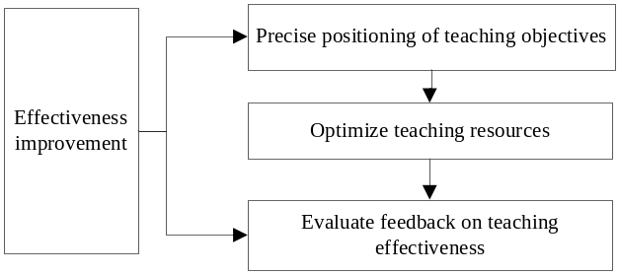
Figure 1 Effectiveness-oriented online art practice teaching course innovation
First of all, the teaching objectives of online art practice teaching should be accurately positioned to ensure that the course content is highly consistent with the teaching objectives by clarifying the course objectives and focusing on the students' core needs and skills enhancement. Secondly, we should actively optimize the teaching resources of online art practice teaching by screening high-quality teaching materials and combining them with practical cases to make the contents more close to reality and easy for students to understand and apply. Finally, we should regularly evaluate and feedback the effect of online art practice teaching, through homework, tests and other ways, regularly assess the learning effect of students, give timely feedback and guidance to help students adjust their learning strategies.
3.2 Interactivity-oriented innovations
The path of innovation of the online art practice teaching course oriented to interactivity is shown in Figure 2.
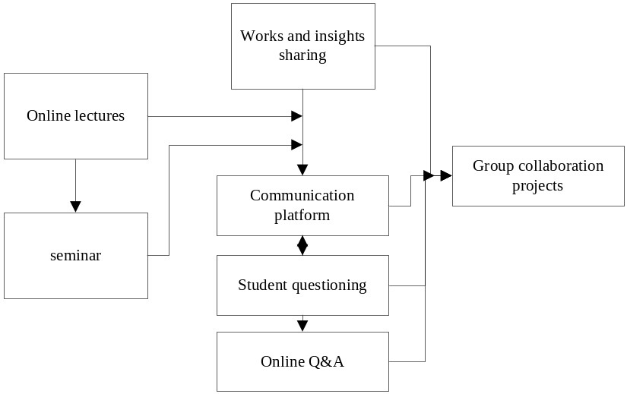
Figure 2 Interactivity-oriented online art practice teaching course innovation
First of all, when establishing an online communication platform, social media, forums and other tools can be actively utilized to build a real-time communication platform between teachers and students, encouraging students to ask questions and share their works and experiences. Secondly, real-time interactive activities can be carried out by organizing regular online lectures, seminars and other activities, and inviting experts or teachers to answer questions online to increase students' participation and interest in learning. Finally, group cooperation programs can be implemented, encouraging students to form groups and complete art creation or research projects together to develop teamwork and communication skills.
3.3 Systemic oriented innovation
The path of innovation of the online art practice teaching curriculum oriented to systematicity is shown in Figure 3.
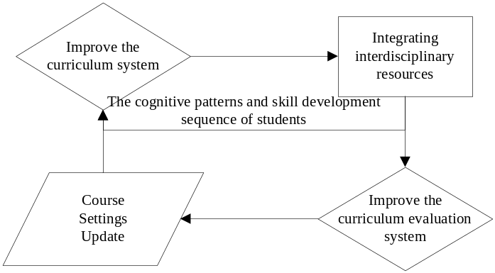
Figure 3 Systematic orientation online art practice teaching course innovation
First of all, it is necessary to build a complete curriculum system and design progressive and interconnected curriculum modules according to the cognitive law and skill development sequence of students. Secondly, we can actively integrate interdisciplinary resources, combine art with other subjects, such as history, culture, science, etc., to form a comprehensive interdisciplinary teaching and broaden students' horizons and thinking. Finally, a perfect curriculum evaluation system should be established to optimize and improve the curriculum system by formulating scientific evaluation standards and methods, and conducting regular evaluation of the implementation effect of the curriculum.
3.4 Process-oriented innovation
The process-oriented, innovative path to the online art practice teaching curriculum is shown in Figure 4.
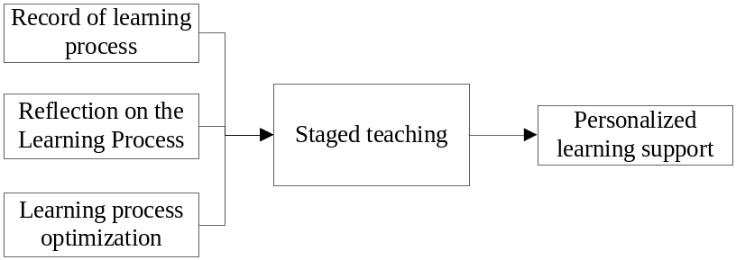
Figure 4 Process-oriented online art practice teaching curriculum innovation
First of all, we should pay attention to the recording and reflection of the learning process of the secondary school community during the online art practice teaching process, requiring students to record their own learning process and creative experience, and to reflect and summarize regularly, so as to promote in-depth learning and self-improvement. Secondly, the curriculum can be divided into several stages, with clear learning objectives and tasks set for each stage to ensure that students learn in a step-by-step and planned manner. Finally, personalized learning support can be provided to students to help them achieve personalized development by providing personalized learning resources and guidance according to their individual differences and learning needs.
4 Conclusion
Online art practice has rich pedagogical and philosophical values in the process of teaching design and implementation. It can not only improve students' art skills and aesthetic ability, but also cultivate students' thinking ability and comprehensive quality, contributing to the overall development of individuals and social progress. This paper proposes the online art practice in teaching design: philosophical reflection and curriculum innovation research, in order to be able to provide reference for the application and promotion of online art practice in teaching, and to provide continuous exploration and innovation of teaching methods and approaches to better meet the learning needs of students and the development needs of society.
References
[1] Keating S A , Vetter M J , Klar R T ,et al.Integrating Climate Change in the Curriculum: Using Instructional Design Methods to Create an Educational Innovation for Nurse Practitioners in a Doctor of Nursing Practice Program[J].The journal for nurse practitioners,2022,18(4):424-428.
[2]LIUBorui.Research on the Innovation of Comprehensive English Curriculum from the Perspective of Blended Learning[J]. The Science of Education, 2022(3):107-110.
[3] Wang A , Zhan Y , Yang Y ,et al.Exploring the Construction of Curriculum Standards for Innovation and Entrepreneurship Education in Higher Education Institutions Based on Curriculum Ideology and Politics[J]. Journal of Contemporary Educational Research, 2022, 6(5):11.
[4] Holme T A .Considering 100 Years of Instructional Innovation in Biochemistry[J].Journal of Chemical Education, 2023, 100(4):1411-1412.
[5] Walsh K S .Belatedness and innovation: Korean modernism[J].Literature Compass, 2023, 20(1):n/a-n/a.
[6] Dan-Yi H .Curriculum Design for College English Majors from the Perspective of Curriculum Innovation-Taking the Course "College English for Entrepreneurs" as an Example[J]. Journal of Literature and Art Studies, 2022, 12(7):744-748.
[7] Xiao H .Innovation of Digital Multimedia VR Technology in Music Education Curriculum in Colleges and Universities[J].Scientific programming, 2022,2022(Pt.14):6566144.1-6566144.9.
[8] Zhu H , Wang Q , Zhou T .The Development Dilemma and Path Choice of Innovation and Entrepreneurship Education Based on Game Theory[J].Advances in multimedia, 2022,2022(Pt.6):1.1-1.11.
[9]YANBaowen,LIXianwen,SONGSongbai,et al.Practice and Exploration of Physical Geography Teaching Oriented to Quality Improvement and Innovation[J]. The Science of Education, 2022(4):137-141.
[10]MAYILAGULIKelimu.Teaching Strategies of Junior High School Chinese Composition under the New Curriculum Reform[J]. The Science of Education, 2022(4):172-175.
[11] Bastiaens E , Jansen A , Heymann P ,et al.A conceptual model of students' reflective practice for the development of employability competences, supported by an online learning platform[J].Education + Training, 2022, 64(3):380-397.
[12] Steed J , Cross K , Wilson B .Collaborating with a Scottish Heritage Brand towards Enhancing and Preserving Sustainable Artisan Hand-Weaving Practices through a Knowledge Transfer Partnership[J].Journal of Textile Design Research and Practice, 2023,11(1/2):127-147.
[13] Catarelli B , Nobles P , Scarton L ,et al.Care, lead, and inspire: Infusing innovation into nursing research and evidence‐based practice course[J].Worldviews on evidence-based nursing, 2023,20(3):281-284.
[14] Zhang S .Enhancing Grammar Learning with a Multimedia Instructional Module:Design and Teaching of"Shì. de"Construction for CFL learners[J]. Chinese Language Teaching Methodology and Technology, 2022, 5(1):1-28. [1] Zhang L , Carter R , Basham J D ,et al.Integrating instructional designs of personalized learning through the lens of universal design for learning[J].J. Comput. Assist. Learn. 2022, 38(6):1639-1656.
[15] Grazioli G , Ingwerson A , Santiago D ,et al.Foregrounding the Code: Computational Chemistry Instructional Activities Using a Highly Readable Fluid Simulation Code[J].Journal of Chemical Education, 2023, 100(3):1155-1163.
[16]INSTRUCTIONAL DESIGN FOR INTERGENERATIONAL AND AGE-INCLUSIVE LEARNING: LESSONS FROM A GERONTOLOGY CLASSROOM[J].Innovation in Aging, 2023,7(Supplement_1):25.
[17] Larkins K , Mansour K , Costello D ,et al.Recommendations for the design of video-based educational interventions as instructional tools in robotic surgical training[J].Journal of robotic surgery. 2023,17(3):779-784.
[18] Byrne M .The 6P4C model: An instructional design conceptual model for delivery of e-learning[J].Journal of professional nursing: official journal of the American Association of Colleges of Nursing, 2023,45(1):7.
[19] Kotecha M C , Staack D , Mcadams D A .Functional Modeling-Based Digital Twin Architecture Representation: An Instructional Example of a COVID-19 Breathalyzer Kiosk[J].Journal of mechanical design, 2022,144(9):091401-091413.
[20] Caneva C , Monnier E , Pulfrey C ,et al.Technology integration needs empowered instructional coaches: accompanying in-service teachers in school digitalization[J].International Journal of Mentoring and Coaching in Education, 2023, 12(2):194-215.
[21] Mehmet D. S , Ronald C. M , Ozlem T ,et al.Explicit and Systematic Scripted Instructional Programs for Students with Autism Spectrum Disorder: An Updated and Extended Review[J].Review journal of autism and developmental disorders. 2023,10(2):203-219.
[22] Erickson M G , Wattiaux M A .Case Study: Introductory Student Onboarding With a Place-Based, Blended Welcome Tour[J].NACTA Journal, 2022,66:123-132.
[123Johann Chevalère, Lazarides R , Yun H S ,et al.Do instructional strategies considering activity emotions reduce students' boredom in a computerized open-ended learning environment?[J].Computers & Education, 2023, 196(Apr.):104741.1-104741.15.
[24] Ahn J , Nguyen H , Lopez J ,et al.Reminders, reflections, and relationships: insights from the design of a chatbot for college advising[J].Information and Learning Sciences, 2023, 124(3/4):128-146.
[25]Yang Y, Zhang M S, Wu B, et al. Design of Simulation System for Discontinuity Network in Rock Mass and Its Application in Teaching [J]. Computer Simulation, 2022, 39(9):5.

